- Homepage: Homepage of Fighters71 is-
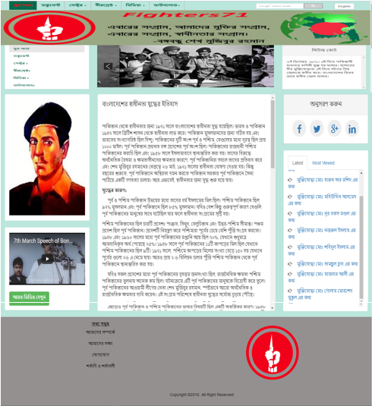
Figure App (a): Project’s homepage

- Document: Document page of Fighters71 is-
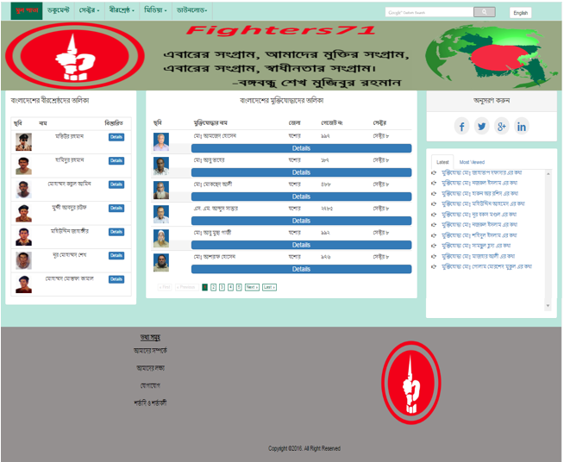
Figure App (b): Project’s document page

- Document Details: Document details page of Fighters71 is-
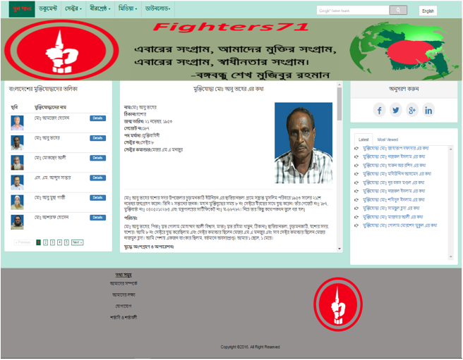
Figure App (c): Project’s document details page

- Sector: Sector page of Fighters71 is-
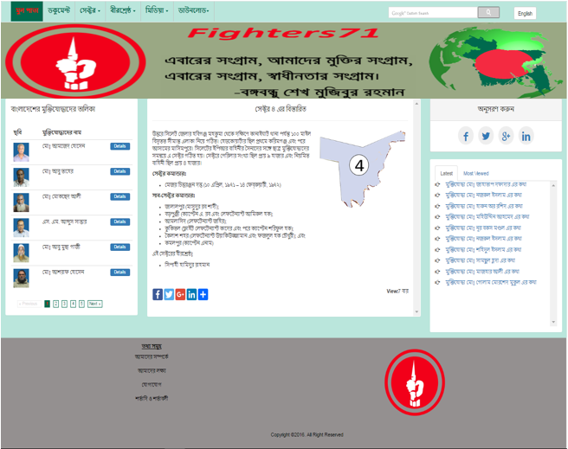
Figure App (d): Project’s sector details page

- Birsrestho: Birsrestho page of Fighters71 is –
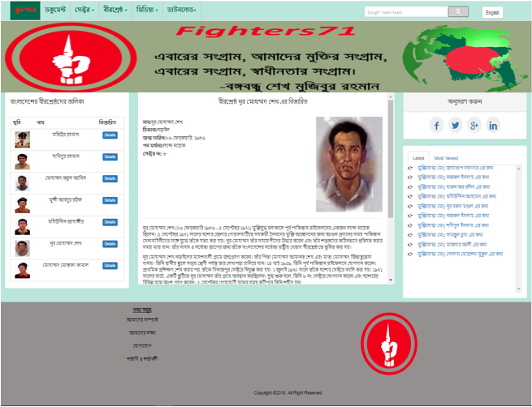
Figure App (e): Project’s birsrestho details page

- Audio: Audio page of Fighters71 is –
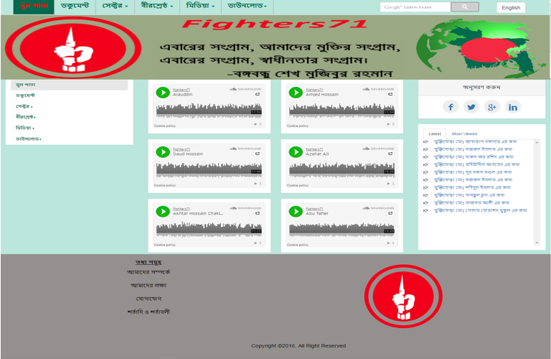
Figure App (f): Project’s audio page

- Video: Video page of Fighters71 is-
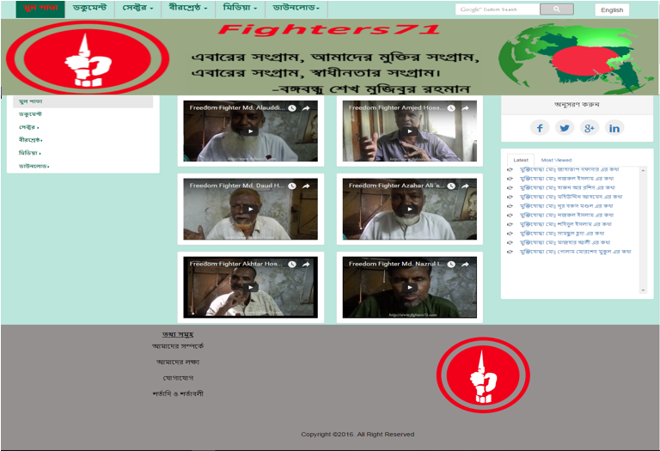
Figure App (g): Project’s video page

- Gallery: Gallery page of Fighters71 is-
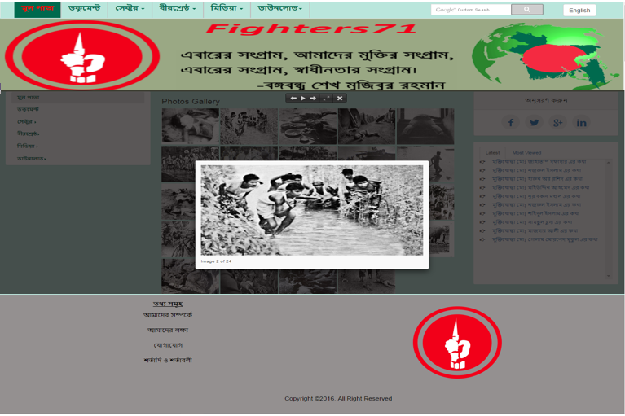
Figure App (h): Project’s photo gallery page

I. E-book: E-book page of Fighters71 is-
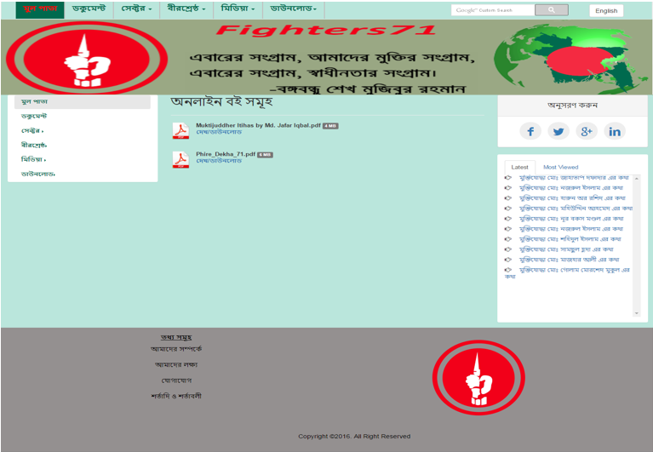
Figure App (i): Project’s e-book page

